**Linux File Editors**

***In Linux, there are two types of file editors: CLI editors and GUI editors, each designed for different user needs.***

***CLI Editors****: These run in the terminal and popular among users for scripting and remote management. Example:* ***Vim/Vi****,* ***Nano****, and* ***Emacs****.*

***GUI Editors****: These have a graphical interface, making them easier for beginners or users who prefer a visual style. Example: include* ***Gedit, GVim****, and* ***Kate****.*

**CLI Editors**

***Edit files with Vi (Visual Editor) / Vim (Vi Improved Editor):***

***Vi/vim Editor:*** *is a powerful text editor available in Linux systems. It operates in three primary modes:*

1. ***Command Mode : See the data***
2. ***Insert Mode : Edit the data***
3. ***Exit Mode : save and exit***

***Insert Mode :***

* When you create a file using the vim or vi editor, it automatically opens the file for editing.
* If the file filename already exists, vim or vi opens the existing file for editing.

**

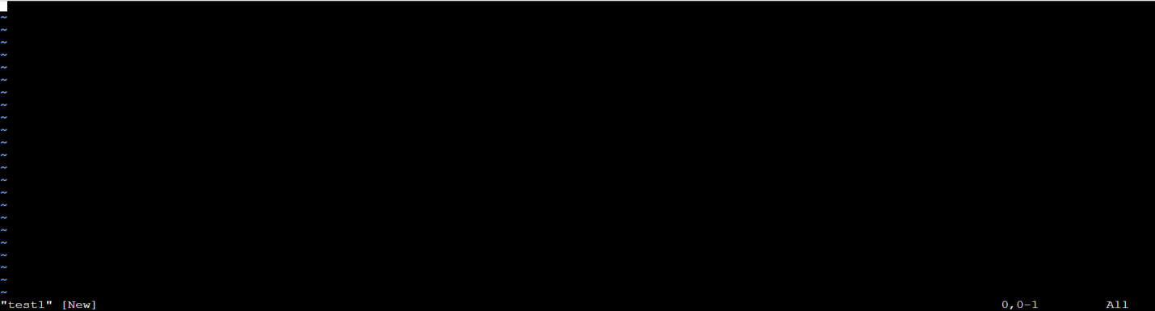

*Press* ***i*** *for insert mode after open file from vi/vim editor.*

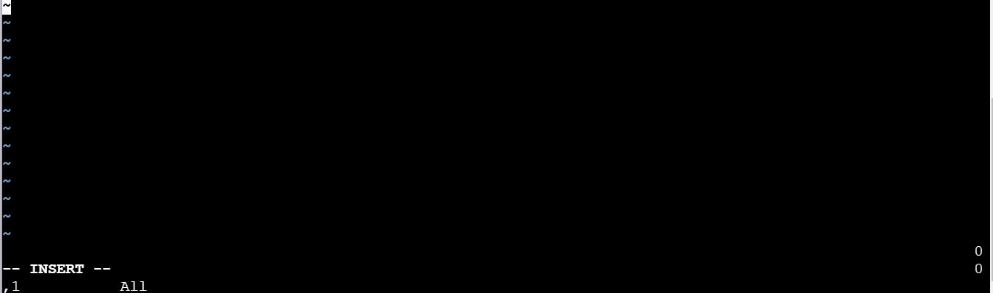

***Options in insert mode :***

***i***  *= Insert the text at current position of cursor.*

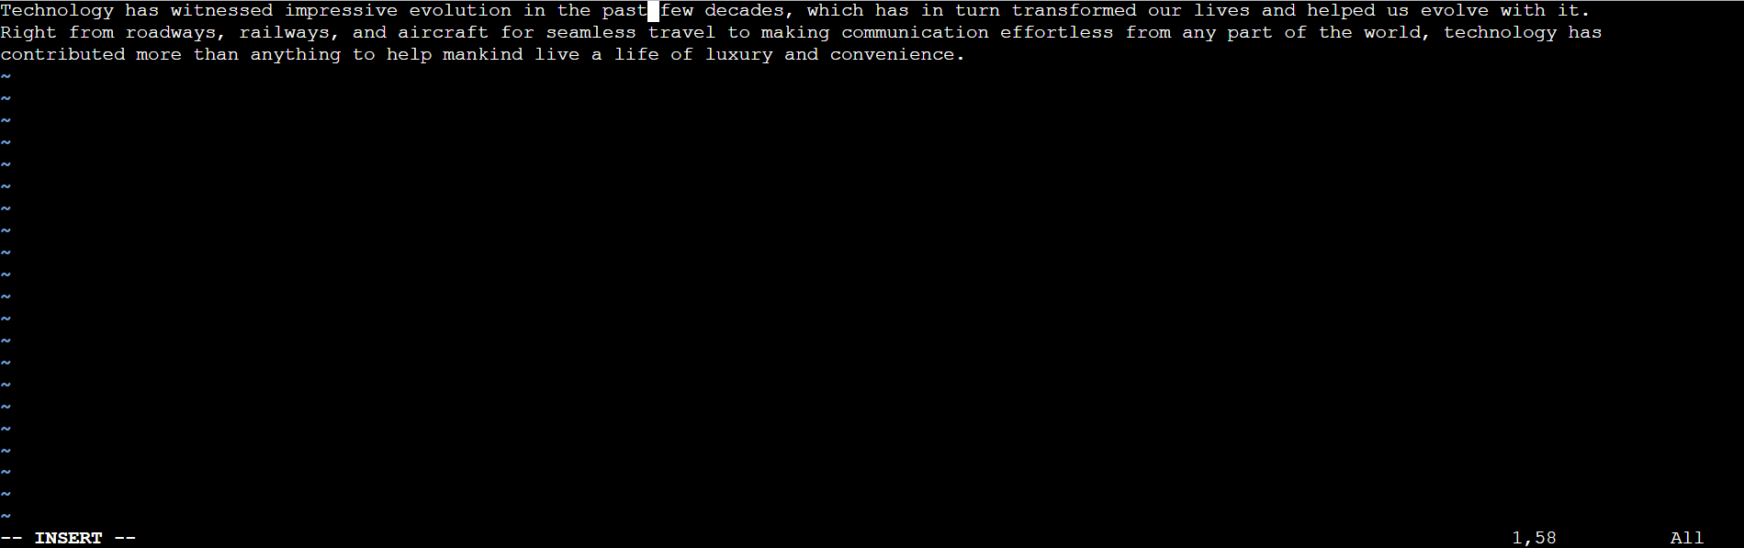

***I*** *= Insert text at the beginning of the current line.*

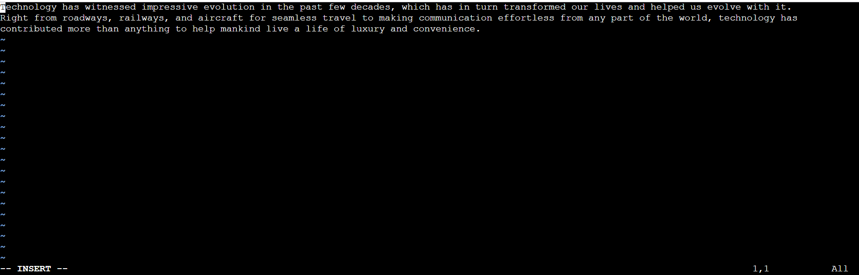

***a*** *= Append after the cursor’s current position.*

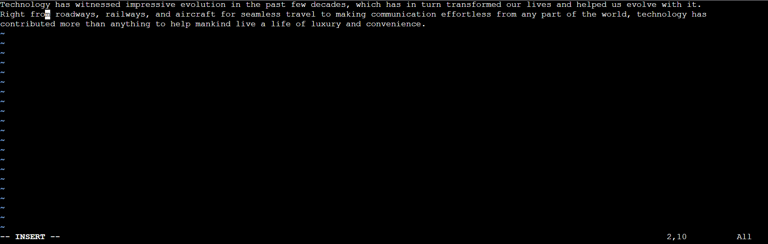

***A****= Append to the end of the line.*

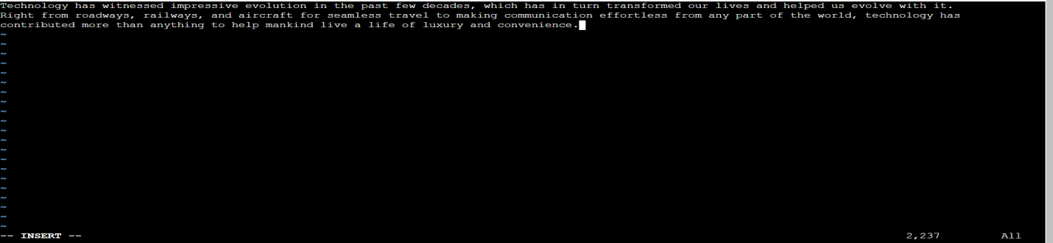

***o*** *= Open a new line under the current line.*

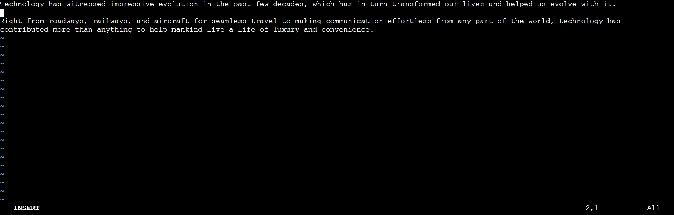

***O*** *= Open a new line above the current line.*

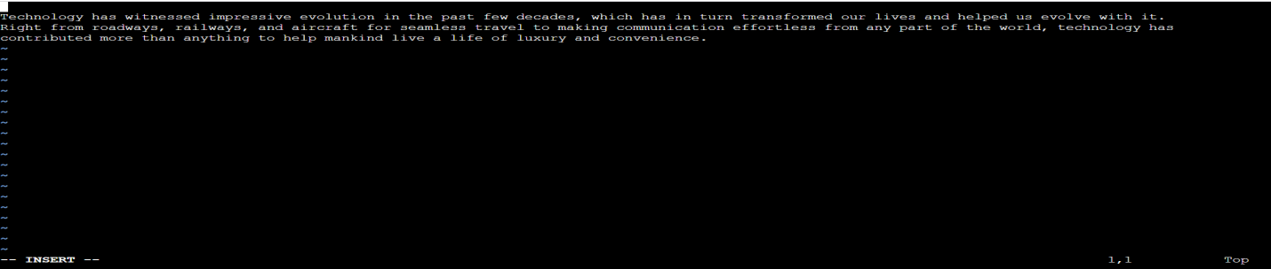

***r***  *= replace a single character.*

**

***Command Mode :***

*Switching from insert mode to command mode: Press the Esc key.*

***Options in command mode :***

***H***  *= Come to beginning of the current page.*

***M*** *= Come to middle of the current page.*

**

***L***  *= Go to end of current page.*

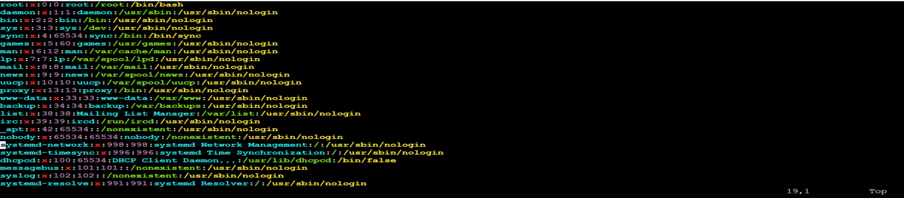

***G***  *= Go to the last line in a file.*

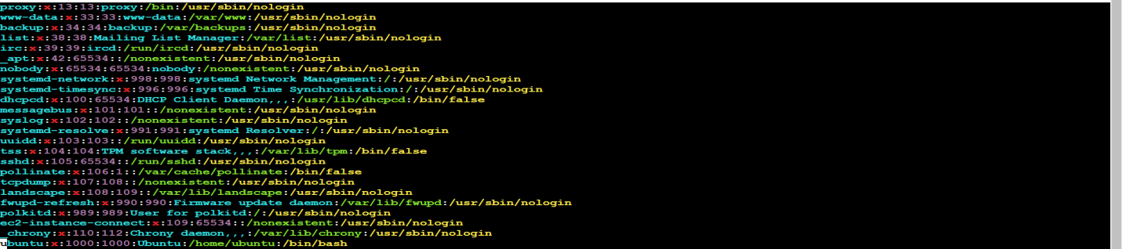

***Ctrl+f***  *= Forward one page.*

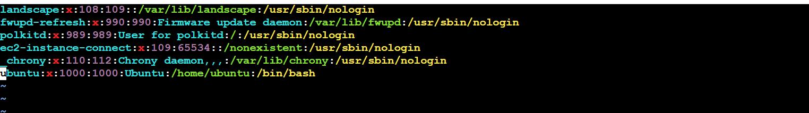

***Ctrl+b*** *=Backward one page.*

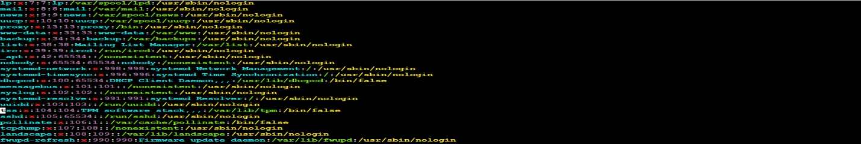

***dd****= Delete a single line.*

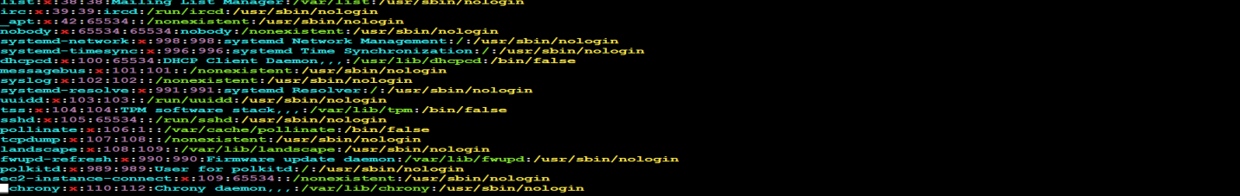

***ndd*** *= Delete n numbers of lines simultaneously. (we can delete any number of line simply give line number)*

***yy****= Copy a single line.*

***nyy*** *= Copy n numbers of lines simultaneously. (we can copy any number of line simply give line number)*

***p****= Paste one time.*

***np*** *= Paste n times.*

**

***u*** *= undo.*

***Ctrl+r***  *= redo.*

***gg*** *= Go to the first line in a file/ move to the starting of file.*

***ng*** *= Go to n number of line in your file. (we can go to any line of file simply type line number in place of n )*

***b****= Go to the beginning of the word.*

***e****= Go to the end of the word.*

***x****= Delete a single character.*

***:num***  *= Display the current line’s line number.*

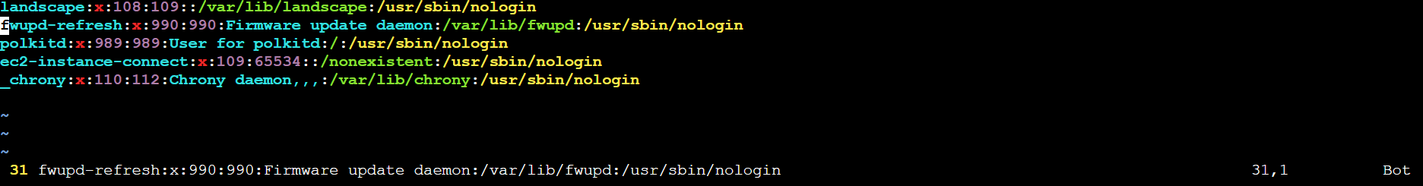

***h****= Move left one character.*

***j****= Move down one line.*

**

***k****= Move up one line.*

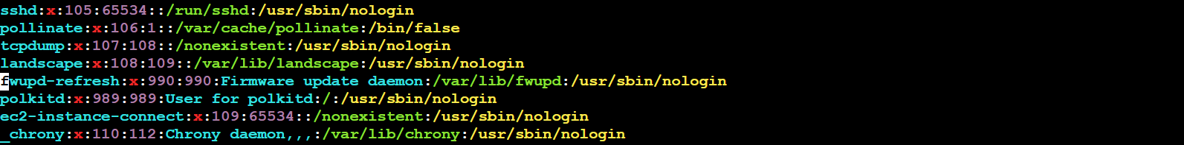

***l****= Move right one character.*

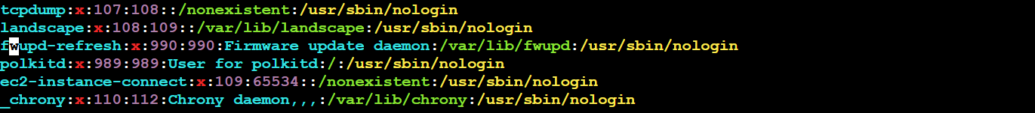

***/text*** *= Search for "text" in the file.*

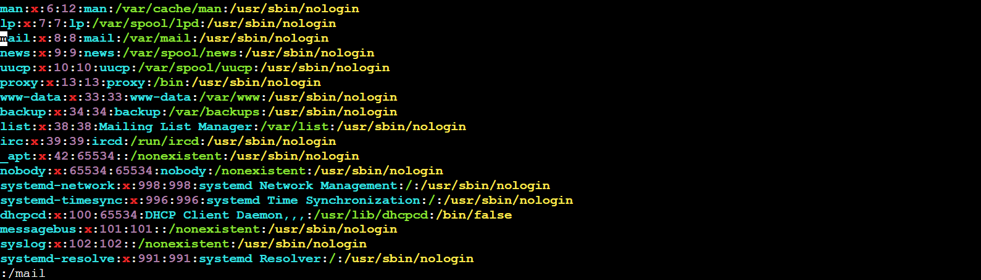

***Exit Mode :***

*Switching from command mode to exit mode: Press the Esc key.*

***Options in exit mode :***

***:w*** *= Save the file.*

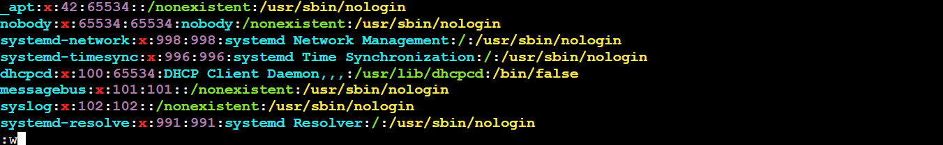

***:q*** *= Quit the editor.*

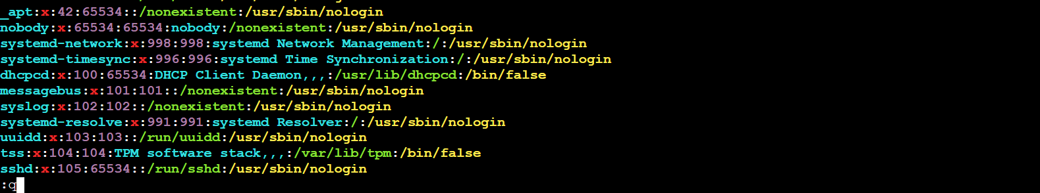

***:wq*** *= Save and quit. We can also use (shift+zz)*

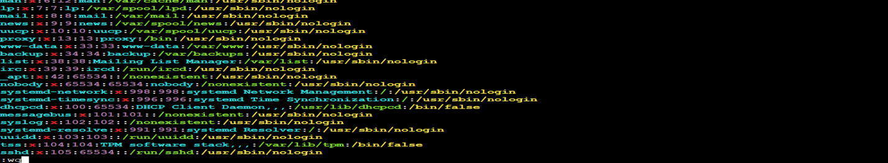

***:q!*** *= Quit without saving changes.*

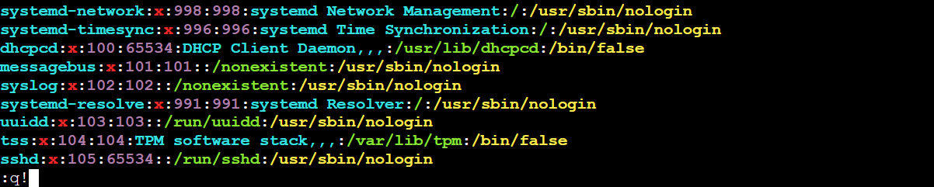

***:wq*** *= Save and exit forcefully.*

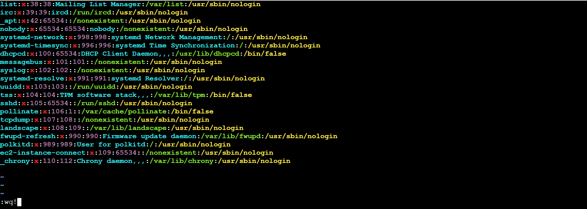

***:se nu*** *= Set line number.*

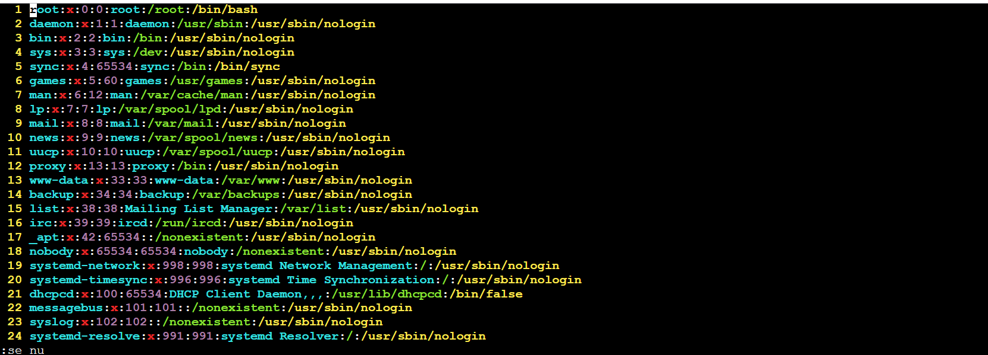

***:se nonu*** *=Remove line number.*

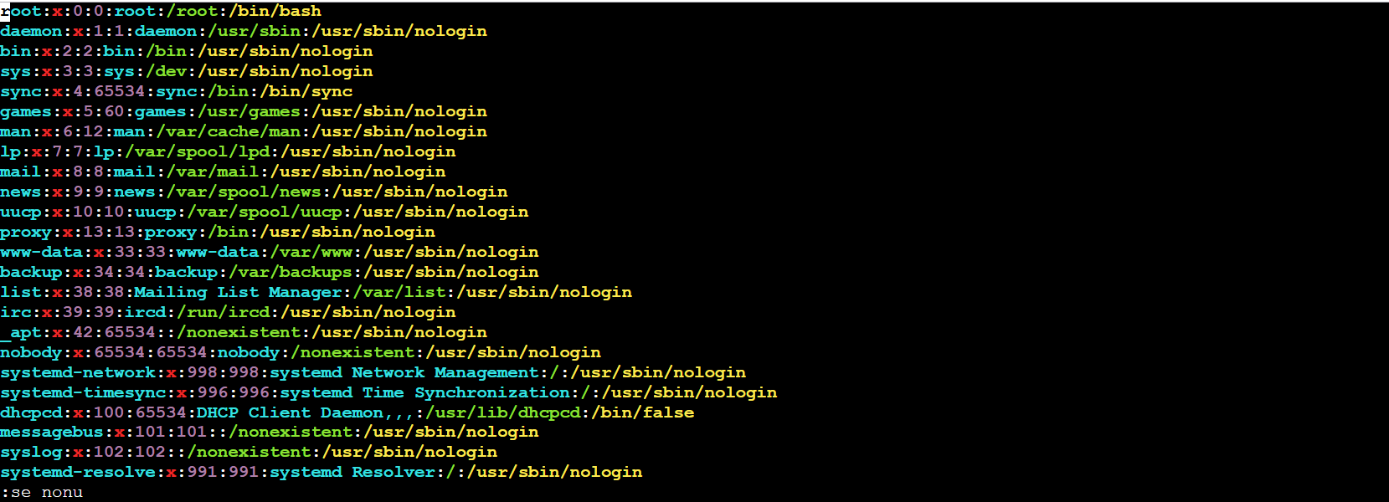

***Edit files with a nano text editor:***

* When you create a file using the nano editor, it automatically opens the file for editing.
* If the file filename already exists, nano opens the existing file for editing.

**

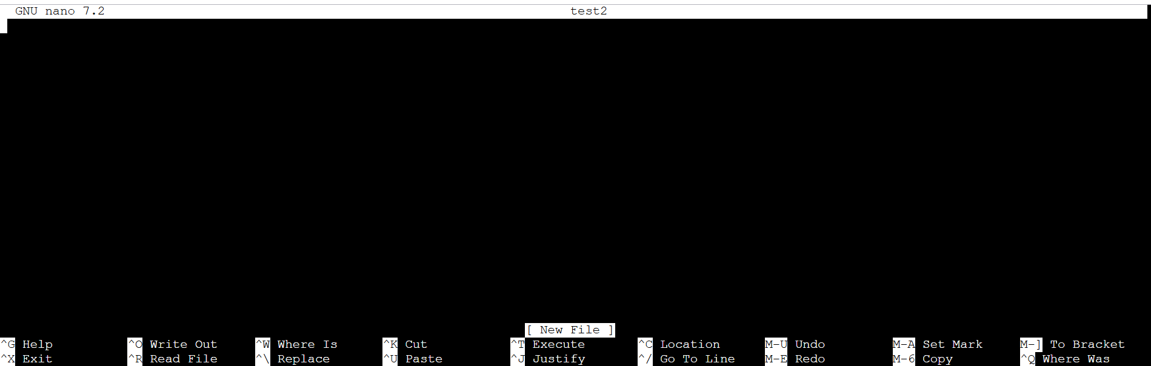

***Exiting from nano editor:***

*In* ***nano****,* ***Ctrl + X*** *(written as* ***^X*** *in the interface) is used to* ***exit the editor***

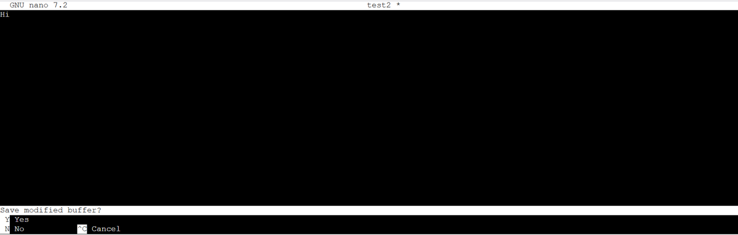

*If you made no changes to the file or don't want to save: Press* ***Ctrl + X*** *, nano will close immediately if no changes were made.*

*Make changes (e.g., type some text):*

* *To save and exit, press* ***Ctrl + X****. Type* ***Y*** *(yes) when prompted. Press Enter to confirm the filename.*
* *If there are unsaved changes, nano will prompt: Type* ***N*** *(No) to discard changes and exit.*

*Exit After Saving:*

* *If you want to save changes before exiting, press* ***Ctrl + X****.*
* *Nano will ask type Y (Yes) to save. Nano will prompt for the filename, Press Enter to confirm and exit.*

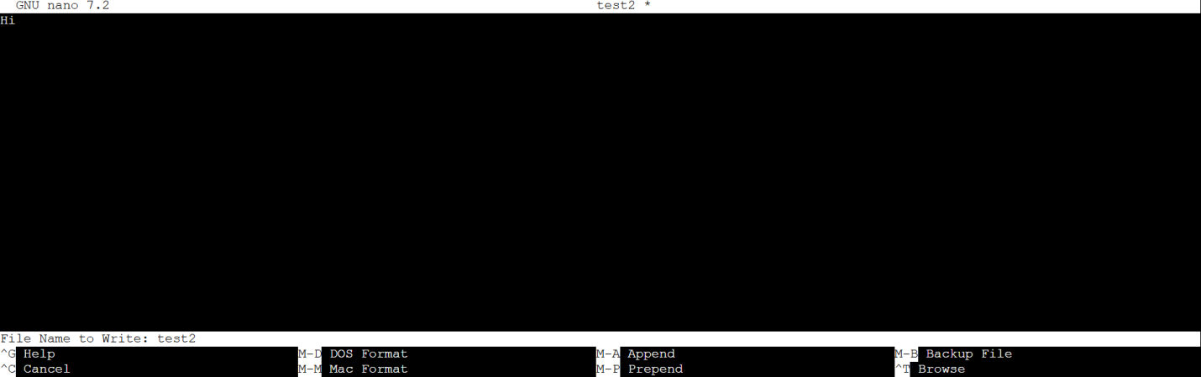

***Options in nano editor :***

**

*What Does* ***^*** *Mean?*

* *In* ***nano****, the ^ symbol represents the* ***Ctrl*** *(Control) key.*
* *It is used for various commands. For example:*

*What Does M Mean?*

* *M stands for the* ***Meta key****, which is typically the Alt key on most keyboards.*
* *Example M-U translates to Alt + U.*
* *Press Alt + U (or Esc, then U if Alt doesn't work).*

*----------------------------------------------------------------------------------------------------------------*

**GUI Editors**

***Edit files with Gedit text editor:***

*We can open our files with GUI editors only when OS have GUI.*

***gedit <filename>***

*Example: gedit cloud*



